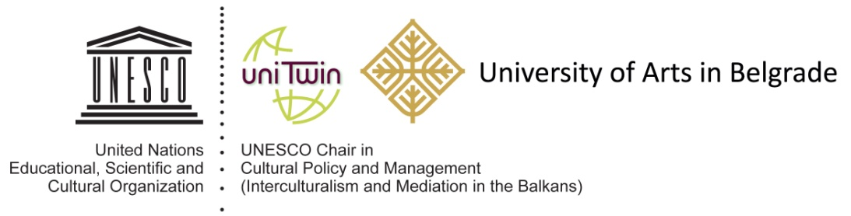

Conference Call

In from the margins – Sharing footnotes of subaltern knowledge and practices:
Questioning North-South relations and ethics of international collaboration

Belgrade 26-28th June, 2023

Contemporary education within cultural, artistic and media field globally is mostly fed by Eurocentric dominant discourses and submitted to a classical epistemological framework, which silences multiple understandings of specific contexts, local knowledge-making systems and practices of cultural creation. Pedagogical, artistic and cultural practices whose methods are based on sensual, intuitive, interdisciplinary, open-ended and experimental practices traditionally get ignored in academic teaching. Knowledge, thus considered, limits the capacity of its various recipients, be they academics, professionals, students, citizens, etc., to appreciate, produce, and use it in an autonomous and emancipated way outside the labelled frames of institutions. The common representation of what knowledge is supposed to be, thus makes alternative or subaltern knowledge invisible and widens the gaps between mainstream, canonized knowledge construction and the more hidden, marginalized ways of producing knowledge.

The notion of “subaltern knowledge”, developed by Gayatri Spivak within what is called Postcolonial Thinking, significantly broadens the boundaries of knowledge towards narrative, corporeal, experiential, sensed, popular, community-based, traditional, non-legitimized forms. Despite decades of post-colonial and decolonial thinking engaging in issues of subalternity, both cultural and educational institutions still hold on to a narrow, cerebral, academic, Euro-centric canons of what is “legitimate” knowledge. How to break away with the self-legitimising practice by those who have power to produce knowledge and transfer it to others? How to engage with subaltern knowledge and perspectives? How can subaltern knowledge be produced, accessed or activated in a respectful and sensitive way within cultural and educational institutions? How can South-North power relations be rethought and reworked so as to lead to ethical and just international cooperation?

This conference wants to challenge the dominant discourse on knowledge and open up discussion on other forms of knowing and sharing, that have been on the margins both within and between societies. We want to discuss ways of constructing, sharing, and using a plurality of knowledge, especially when educating new generations of culture and media professionals, with the desire to make cultural and media field more sensitive, plural, inclusive and just.

In doing this, we invite the global community of cultural activists, researchers, scholars, teachers, artists and cultural operators, to submit their ideas and abstracts for this conference, its workshops and other forms of presentations. We welcome a broad range of contributions that go beyond classical academic papers, providing direct subaltern or activist perspectives (experiences, project proposals, art works, educational presentations and workshops, policy measures, etc.). The forms include but are not limited to:

- reflection and/or research papers that provide theoretical and empirical insights (from the standpoints of different disciplines or transgressing disciplinary frameworks: cultural policy, cultural and media studies, communication studies, philosophy, sociology, cultural management…)
- artistic and practical individual or collaborative works (photography, video, performances, lecture/performances, manifestos, installations, curated multimedia, etc.)
- pedagogical, training and learning formats that explore different dimensions of teaching and learning process that deals with subaltern knowledge, decolonising university and its teaching and learning forms...

Keynote speakers:

Marcia Tiburi, Brazilian artist, professor of philosophy, University Paris 8
Gerty Dаmbury, writer, educator and theatre director from Guadalupe, founder of the artistic collective Décoloniser les arts Paris
Basma El Husseini, Action for hope, Beirut

Possible topics for all kinds of contributions:

- Epistemic injustice – a critical perspective of hegemonic knowledge
- Situatedness in knowledge production: peripheral perspectives
- Ecology of knowledges and knowledge sharing
- Arts and subaltern, marginalized, excluded
- Artistic engagement / collective imaginaries
- (Un)framing knowledge – Shaking the institution
- Participatory research: an agenda that shakes academic norms
- New ethics in cultural communication and collaboration
- Fairness in international cultural cooperation: questioning North-South relations
- Fairness in international cultural cooperation: involving “invisible” communities
- Decolonising cultural policies – introducing plural perspectives in official frameworks
- Culture of memory: decolonial perspectives and practices in arts and cultural sector
- Subaltern cultural practices in public and counter-public realms: new models, self-organisation, anti-institutional practices
- Digital world: is subaltern excluded from techno utopias?
- Practice-based alternatives for subaltern knowledge production and sharing
- Arts-based methods and subaltern research (art-based research practice)
- Subaltern knowledge production and its integration in academic circuits
- Subaltern perspectives in teaching
- Methods and modes of subaltern teaching and learning
- Performative learning: body and movement in education
- Diffractive pedagogies and imaginaries
- Material/materiality in artistic and educational practices
- Community embedded educational cultures
- Digital pedagogies: closing or opening new doors
- Politics of care and hospitality
- Policies of solidarity in a public realm

The suggested topics are here to inspire but are not limiting any contribution that addresses issues relevant to the conference theme.

The papers of the conference will be considered for publishing by the European Journal of Cultural Management and Policy (open access journal) as well as in the Conference Proceedings Book.

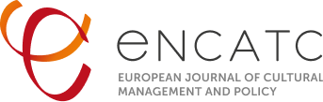

Application Procedure

Submission of the proposals: by April 1st 2023, 00h Central European Time
Decisions on the acceptance of proposals: by 20th April 2023
Conference registration: by 20th May 2023

Please send your abstract (max. 300 words without references or images), a short biography (max. 100 words), and your affiliation-location in a single PDF file to shakin.conference@arts.bg.ac.rs. Abstracts for research papers must clearly state your research question(s), theoretical framework, methodology and max 5 keywords. Abstracts for workshops, art works and other forms of presentations should clearly state the issues in focus, as well as methods, format of presentation, including 5 keywords.

In accordance with the values of the SHAKIN’ project registration is free of charge.
Accommodation and travel costs should be covered by the participants.

The official language of the conference is English, but Serbian would be possible for specific workshops and artworks.

*Please add the aforementioned email address to your list of safe contacts.

Conference background:

This conference is a final multiplier event of the project “Sharing subaltern knowledge through international cultural collaborations” (SHAKIN’) supported by the EU’s Erasmus+ program, Strategic Higher Education Partnerships for Innovation.
The project is carried out by six partners from four countries (France, Germany, Serbia, Sweden): three universities (University Lumière Lyon 2, Bauhaus-University Weimar, University of Arts Belgrade) and three cultural organizations (Association Independent Cultural Scene Serbia, Stockholm Museum of Women’s History, le LABA), all of them being internationally recognized in their domain of activity.
The project has dealt with finding new ways to think, work and collaborate, addressing crucial contemporary challenges affecting European culture fields in order to provide students with adequate professional ethos for the jobs of tomorrow. Throughout the project we have engaged with perspectives, knowledges, methods of learning and knowledge sharing which are on the margins of the current dominant ways of schooling and professionalizing in culture and media fields.

Organization of the Conference

The Conference is organised by the UNESCO Chair in Cultural Policy and Management of the University of Arts in Belgrade in collaboration with the Association of Independent Culture of Serbia (AICS).

Conference programme board:

Milena Dragićević Šešić (University of Arts Belgrade) and Sarah Coordonnier (University Lyon II), co-presidents
Eva Krivanec, University of Weimar
Camille Jutant, University of Lyon II
Višnja Kisić, University of Arts Belgrade
Goran Tomka, University of Arts Belgrade
Nina Mihaljinac, University of Arts Belgrade
Marijana Cvetković, AICS, Belgrade
Anna Tascha Larsson, Stockholm Museum of Women’s History
Pierre Brini, LABA, Bordeaux
Avril Joffe, de Witts University South Africa
Pascal Gielen, University of Antwerp, Belgium
Lluis Bonet, University of Barcelona
Bojana Videkanic, University of Waterloo, Ontario Canada
Monika Mokre, Austrian Academy of Sciences
Svetlana Hristova, South-West University in Blagoevgrad
Dunja Babović, secretary of the Program Board of the Conference

